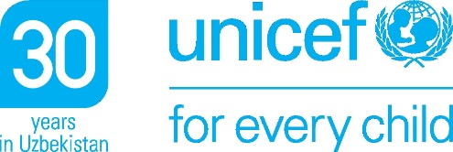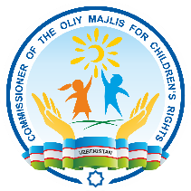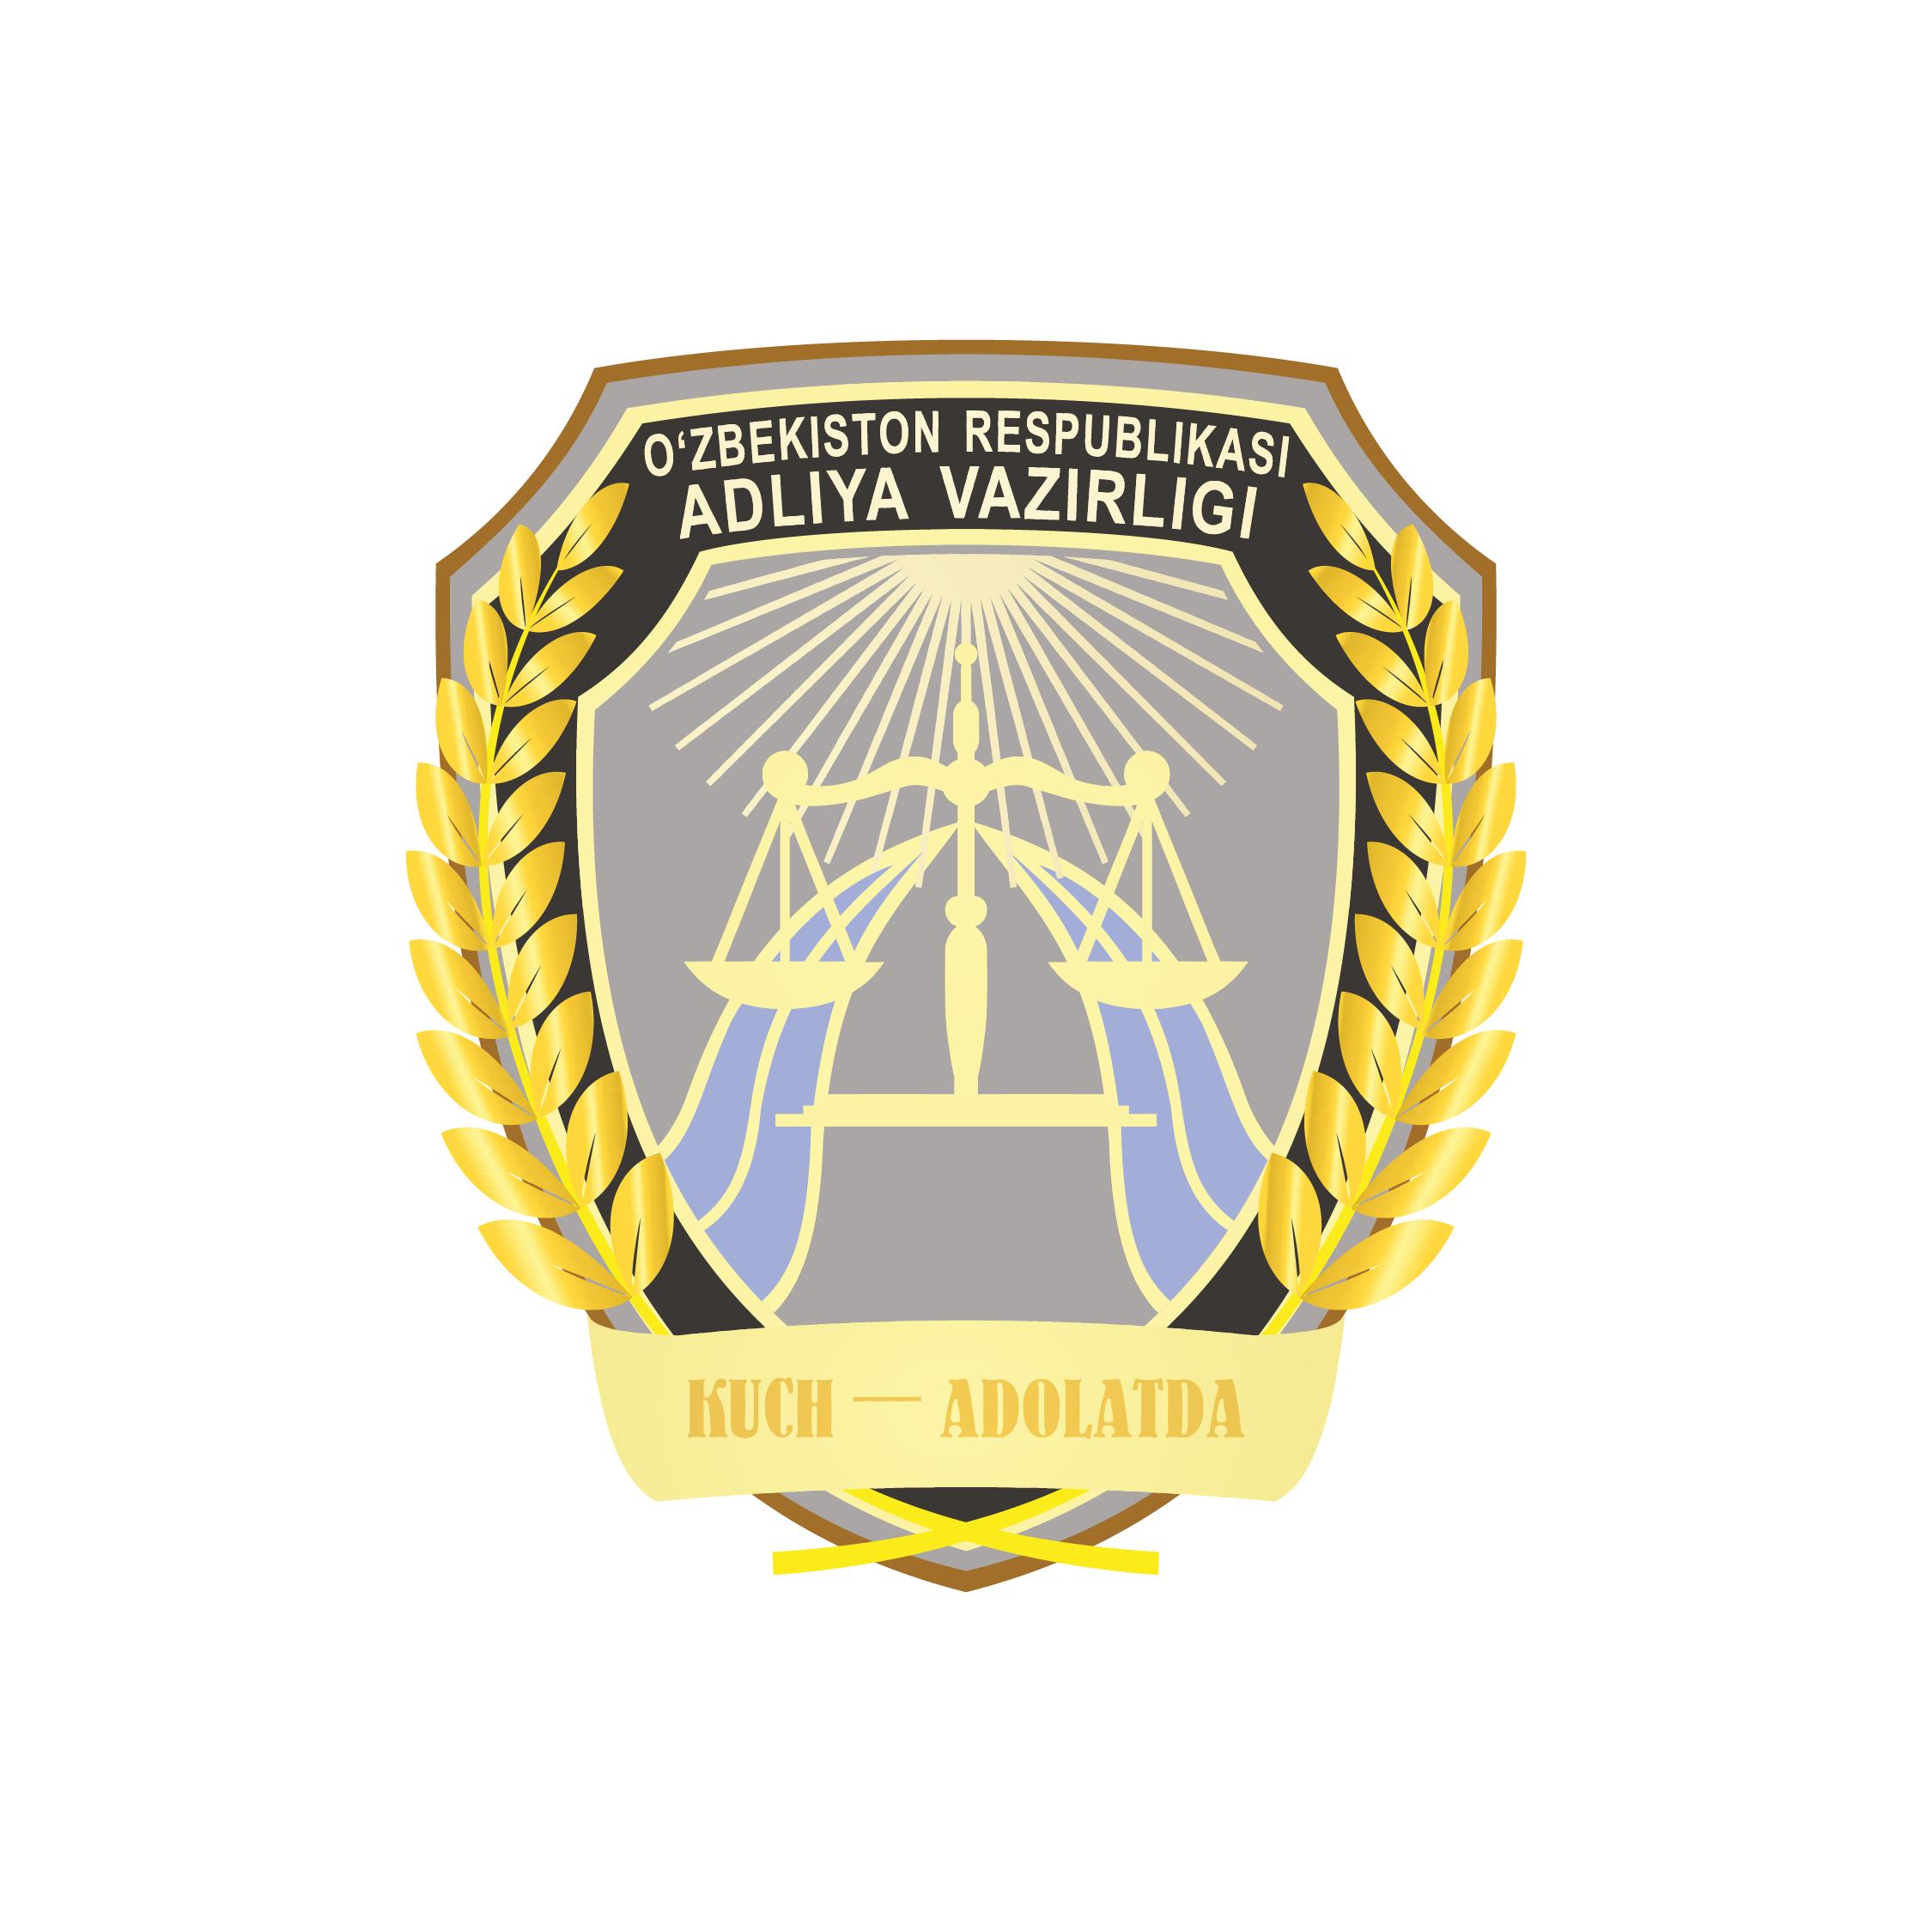***PRESS RELEASE***

**Child-friendly justice system driven by specialized expertise imperative for delivering on child rights in Uzbekistan**

*Experts discuss the ways of improvement of access to justice for children in Uzbekistan.*

**TASHKENT, 4 June 2024** –In a bid to respond to the latest concluding observations and recommendations of the UN CRC Committee on Uzbekistan’s Fifth State Party Report on the implementation of the Convention on the Rights of Child, UNICEF, the office of the Child Ombudsperson and the Ministry of Justice, today convened a round table on ensuring a child-friendly justice system across Uzbekistan.

The observations called upon Uzbekistan to establish a specialized comprehensive child justice system backed by adequate human, technical and financial resources, including well trained designated specialized judges and prosecutors for children.

The roundtable brought together deputies of the Legislative Chamber, members of the Senate of the Oliy Majlis, representatives of state bodies, civil society institutions, and international organizations to discuss ways of improvement of justice for children in Uzbekistan.

“Awareness of representatives of the legal community and the public about the international aspects of protecting children's rights is still insufficient. Often, specialists who do not have sufficient experience and knowledge in this area cannot effectively protect the rights and interests of minors. Therefore, it is important to improve the level of professional training of legal personnel in this area and increase the capacity of specialists who directly interact with children”, said Esemurat Kanyazov, Director of the Center for Advanced Training of Lawyers.

International experts from Europe and Central Asia shared best practices and provided recommendations to adopt specialized legislation, procedures, and processes as well as establishment of specialized institutional frameworks.

“It is difficult to speak of achieving true justice unless children entering any judicial proceedings are reliably provided with the tools to protect their rights. This requires full access to effective legal aid, representation and support services for children in judicial proceedings, whether criminal, civil or other”, said Children's Ombudsman Surayyo Rakhmonova. “Ensuring children's access to justice requires working in a holistic manner”, she added.

Specialization of legislative frameworks, institutions and professionals working with children in conflict with the law, child victims and witnesses of crimes, children participating in civil and administrative proceedings implies that the legal systems are adapted to the needs, vulnerabilities, age, gender and specific circumstances of every child.

“A child-friendly justice system backed by specialized technical expertise for children means quick, effective, and fair response that protect children’s rights,” said Regina Maria Castillo, UNICEF Representative in Uzbekistan. “It means children are treated with dignity and compassion. It means that justice professionals are knowledgeable about child rights, principles, and standards on justice for children, and skilled to deal with cases in the best interests of every child.”

Participant of Round table recommended the key actions such as:

* specialization of criminal and civil justice systems;
* introducing child-friendly and gender-sensitive procedures and processes;
* extension of the provision of state guaranteed free legal aid to all categories of children in contact with the law and justice systems;
* building national cadres of specialized lawyers and paralegal services;
* improving availability, quality and use of data on children’s experiences in legal and judicial proceedings to strengthen planning, evidence-based policymaking, budget allocation, monitoring and evaluation of policies on children’s access to justice.

**Media contacts:**

|  |  |
| --- | --- |
| Ilhom Farmanov  Сhief Сonsultant  Ministry of Justice  Phone: +99833 988 60 88  E-mail: [i.farmanov@adliya.](mailto:i.farmanov@adliya.uz)uz | Rushana Aliakbarova  Press Secretary  Child Ombudsman Office  Phone: +99894 600 11 72  E-mail: [murodullayevna1999@gmail.co](mailto:murodullayevna1999@gmail.col)m |
| Safinas Ahayeva  Child Protection Specialist  UNICEF Uzbekistan  Phone: +99893 550 52 82  E-mail: [sahayeva@unicef.org](mailto:sahayeva@unicef.org) | Nargiza Egamberdieva  Communication Officer  UNICEF Uzbekistan  Phone: +99893 380 34 19  E-mail: [negamberdieva@unicef.org](mailto:negamberdieva@unicef.org) |